Student Application Form
In order to give us a better understanding of your needs please fill the form in as completely as you can.
Personal details

Name | Date of birth
Residential address | Telephone numbers
Which gender do you identify with?

Which pronouns do you prefer?

Email

Other Contacts

Contact person 1 e.g. emergency

Relationship

Telephone / mobile numbers

email

Mailing address (for reports etc. if email is not preferred)

Contact person 2

Relationship

Telephone / mobile numbers

email

Mailing address (for reports etc. if email is not preferred)

Circumstances and background information

Living arrangements (at home, group home, independent etc.)

Parents (address, level of contact, quality of relationship etc.)

Other family (address, level of contact, quality of relationship etc.)

Other significant people (residents, Rowan students, friends etc.)

Day activities or employment – current

Monday

Tuesday

Wednesday

Thursday

Friday

Day activities or employment – past

Previous training courses and qualifications

Who can we go to for further information?

Hobbies and interests (likes and dislikes, art experience etc.)

Who can we go to for further information?

Social Interactions (e.g comfort level in groups)
(Please attach any relevant reports)

Who can we go to for further information?

Challenging behaviours
(Please attach any relevant reports)

Who can we go to for further information?

Medical issues and medication details
(Please attach any relevant reports, inc. Eating and Swallowing Care Plans)

Who can we go to for further information?

Allergies

Who can we go to for further information?

Relevant existing diagnoses
(Please attach any relevant reports)

Who can we go to for further information?

Communication skills profile

Do you use signing?

Yes

No

Listening / attention | Understanding
Expression (verbal, non-verbal, other) | Other things we need to know about communication (Will you ask? Respond? Initiate? Give information?)
Who can we go to for further information?

Photo permissions

Are you happy for photos of yourself to be used externally in the public domain, while you are a student at Rowan and after you leave?

This could be in printed publications such as brochures, newsletters and annual reviews, images on website, use in press and media (e.g. newspaper), images on our social media, and for use by a third-party organisation, working in partnership with Rowan.

Yes

No

Are you happy for photos of yourself to be used internally, while you are a student at Rowan and after you leave?
This could be as a record of your work for yourself, and for social care reviews.

Yes

No

Trips

Are you happy to go on trips away from Rowan with Rowan staff?

Shopping | Yes  No
Galleries / exhibitions | Yes  No
Art field trips | Yes  No
Meetings / events | Yes No
Local walks | Yes  No

What are your travel arrangements? (How will you get to and from Rowan?)

Other information

Our charges are £60 for a full day and £30 for a half day.

Our morning sessions run 09:00 to 12:00 and our afternoon sessions run 12:00 – 15:00, Monday to Friday. This includes break time. Students bring their own lunch.

Process

Prior to any decision being made to offer a place, you are required to:
- Fill in this form as completely as possible and return it to Rowan.
- Come and look around the studios / workshops at Rowan.
- Participate in a couple of free taster sessions, so that you can experience Rowan activities and meet our staff and other students.

Decision making

- We will use all information to decide if we can offer you a place at Rowan – we will keep you informed along the way. We will discuss our decision with you.
- If a place is agreed, funding must be in place before you start at Rowan.

Please send completed application form to:

Gordon Mackenzie
Rowan
40 Humberstone Road
Cambridge
CB4 1JG
gordon@rowanhumberstone.org.uk
01223 566027 (Monday to Friday)
To arrange for an initial look around or for further information, please contact:

Abi Moore
Rowan
40 Humberstone Road
Cambridge
CB4 1JG
abi@rowanhumberstone.org.uk
01223 566027 (Tuesday to Friday)

Completed by | Signature
Who is commissioning this service? Please give details for invoicing and reference

Date | Telephone | Email

Please note we cannot progress this application without this information.

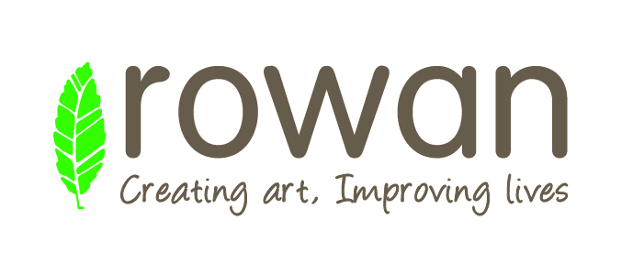
Information sharing permission

Applicant name

I give permission for Rowan to contact the following people for information in support of my application. I am happy for relevant information to be shared with Rowan.

- Name / organisation name

Address

Phone Number

Email

- Name / organisation name

Address

Phone Number

Email

Signature

Date

